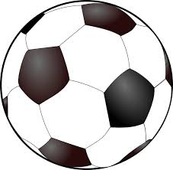INGLISE KEELE SÕNAD

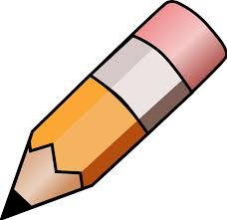Ühenda sobiv sõna pildiga

APPLE

THIS IS AN APPLE

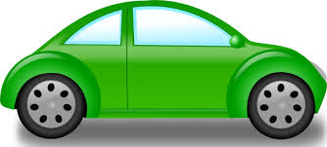BANANA

THIS IS A BANANA

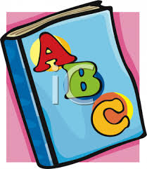BALL

THIS IS A BALL

PENCIL

THIS IS A PENCIL

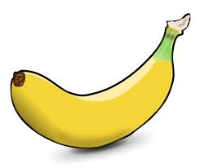

CAR

THIS IS A CAR

BOOK

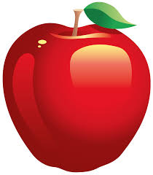THIS IS A BOOK